SPS IPC Drives 2014 (Hall 7, Stand 380)

New MR-J4-TM servo controller enables connection of Mitsubishi Electric servo technology to open networks

Nuremberg / Ratingen, 25. November 2014

At this year's SPS IPC Drives, Mitsubishi Electric on stand 7-380 will be presenting the new MR-J4-TM servo controller that can be combined with Anybus plug-in cards from e-F@ctory Alliance partner HMS Industrial Networks. With this solution, Mitsubishi Electric enables its servo technology to be used with third-party control system and network technologies for the first time so that machine manufacturers will be able to enjoy all the benefits of the highly compact, powerful technology from Japan at any time. The HMS plug-in card ensures the compatibility required.

Machine manufacturers are often bound to certain manufacturers' components based on customers' specifications. However with the MR-J4-TM servo amplifier based on MR-J4 technology, even if they do need to use a certain control system, system manufacturers can still use Mitsubishi Electric servo technology which offers significant benefits in terms of saving space and design flexibility, for example. Then there are the special functions of the MR-J4 series such as the first and second-level vibration suppression or the one-touch tuning function.

Oliver Giertz, Product Manager Servo/Motion/Robot, Mitsubishi Electric Europe B.V., explains: "Servo technology is one of our core competences. If you compare Mitsubishi Electric servo products with those of European manufacturers in terms of size and power, for example, you will find that the power density of our components is 30 to 40 per cent higher. What that means is that while Mitsubishi Electric products offer the same or a higher level of performance, they are only half the size of the other manufacturers' products. Machine manufacturers will appreciate the resulting benefits. In HMS, we found a strong partner to work with on the development of the MR-J4-TM servo controller and the implementation of the network technology."

The first version of the MR-J4-TM has an HMS EtherCAT plug-in card. The next one will be a PROFINET variant and further options will follow. This technology enables a machine to be adapted for use with various Ethernet systems quickly and easily and consequently made suitable for worldwide use with different types of control system and network technology.

Image Caption:
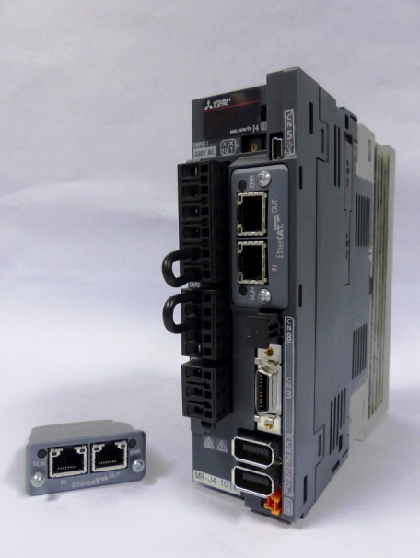
The new MR-J4-TM servo controller enables Mitsubishi Electric servo technology to be connected to open networks for the first time. [Source: Mitsubishi Electric Europe B.V.]

Note to Editor: if you would like the text in another language please contact Nicola Bigmore at DMA Europa – nicola@dmaeuropa.com.

About Mitsubishi Electric
With over 90 years of experience in providing reliable, high-quality products to both corporate clients and general consumers all over the world, Mitsubishi Electric Corporation is a recognized world leader in the manufacture, marketing and sales of electrical and electronic equipment used in information processing and communications, space development and satellite communications, consumer electronics, industrial technology, as well as in products for the energy sector, water and waste water, transportation and building equipment.
With around 124.000 employees the company recorded consolidated group sales of 39,3 billion US Dollar* in the fiscal year ended March 31, 2014.
Our sales offices, research & development centres and manufacturing plants are located in over 30 countries.
Mitsubishi Electric Europe B.V., Factory Automation European Business Group (FA-EBG) has its European headquarters in Ratingen near Dusseldorf, Germany. It is a part of Mitsubishi Electric Europe B.V., a wholly owned subsidiary of Mitsubishi Electric Corporation, Japan.
The role of FA-EBG is to manage sales, service and support across its network of local branches and distributors throughout the EMEA region.
*Exchange rate 103 Yen = 1 US Dollar, Stand 31.3.2014 (Source: Tokyo Foreign Exchange Market)

Further Information:
Website: eu3a.mitsubishielectric.com/fa
YouTube: http://www.youtube.com/user/MitsubishiFAEU
Twitter: https://twitter.com/MitsubishiFAEU

Press contact:
Mitsubishi Electric Europe B.V.
Factory Automation European Business Group
Monika Torkel
Marketing Communications Coordinator
Gothaer Str. 8
40880 Ratingen, Germany
Tel.: +49 (0)2102 486-2150
Fax: +49 (0)2102 486-7170
Monika.Torkel@meg.mee.com

PR-Agentur:
DMA Europa Ltd.
Mr. Roland Renshaw
Europa Building, Arthur Drive, Hoo Farm Industrial Estate, Kidderminster, Worcestershire, UK
Tel.: +44 (0) 1562 751436
Fax: +44 (0) 1562 748315
roland@dmaeuropa.com
www.dmaeuropa.com

